**DA Assignment - 1**

The growth of supermarkets in most populated cities is increasing and market competitions are

also high. The data set is one of the historical sales of supermarket company which has

recorded in 3 different branches for 3 months data.

**Attribute information**

Invoice id: Computer-generated sales slip invoice identification number

Branch: Branch of super center (3 branches are available identified by A, B and C).

City: Location of super centers

Customer type: Type of customers, recorded by Members for customers using member

cards and Normal for those without member cards.

Gender: Gender type of customer

Product line: General item categorization groups - Electronic accessories, Fashion

accessories, Food and beverages, Health and beauty, Home and lifestyle, Sports and

travel

Unit price: The price of each product in $

Quantity: Number of products purchased by the customer

Tax: 5% tax fee for customers buying

Total: Total price including tax

Date: Date of purchase (Record available from January 2019 to March 2019)

Time: Purchase time (10 am to 9 pm)

Payment: Payment used by the customer for the purchase (3 methods are available –

Cash, Credit card and Ewallet)

COGS: Cost of goods sold

Gross margin percentage: Gross margin percentage

Gross income: Gross income

Rating: Customer stratification rating on their experience (scale of 1 to 10)

Task:

Upload the dataset , delete the unnecessary columns if required

Create below Visualistion:

● Pie Chart

Stacked Bar Chart

● Line Chart

● Simple Table Chart

**Visuals:**

**Pie Chart**

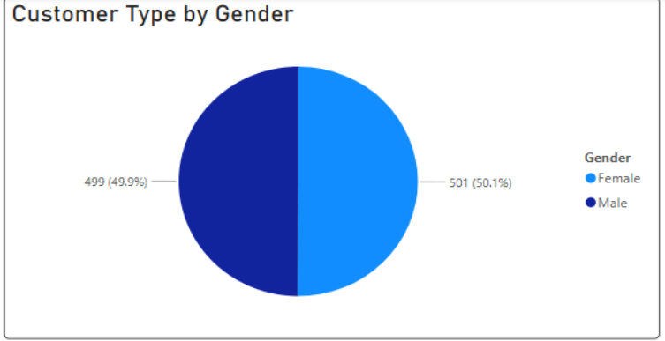

**Stacked Bar Chart**

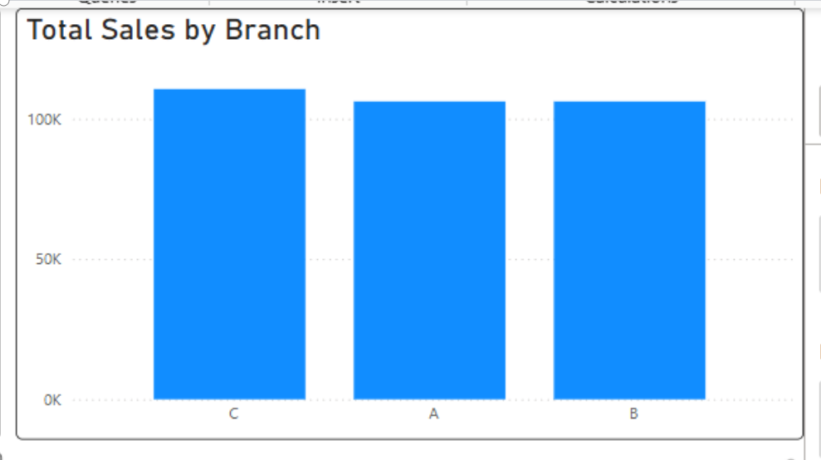

**Line Chart**

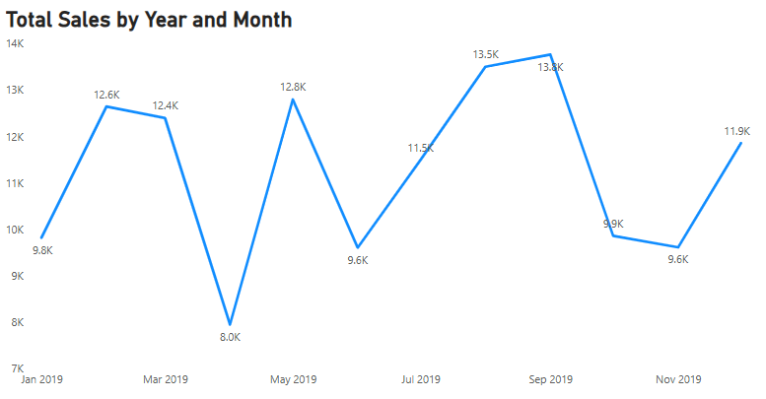

**Simple Table Chart**

